Spray Bottle Model

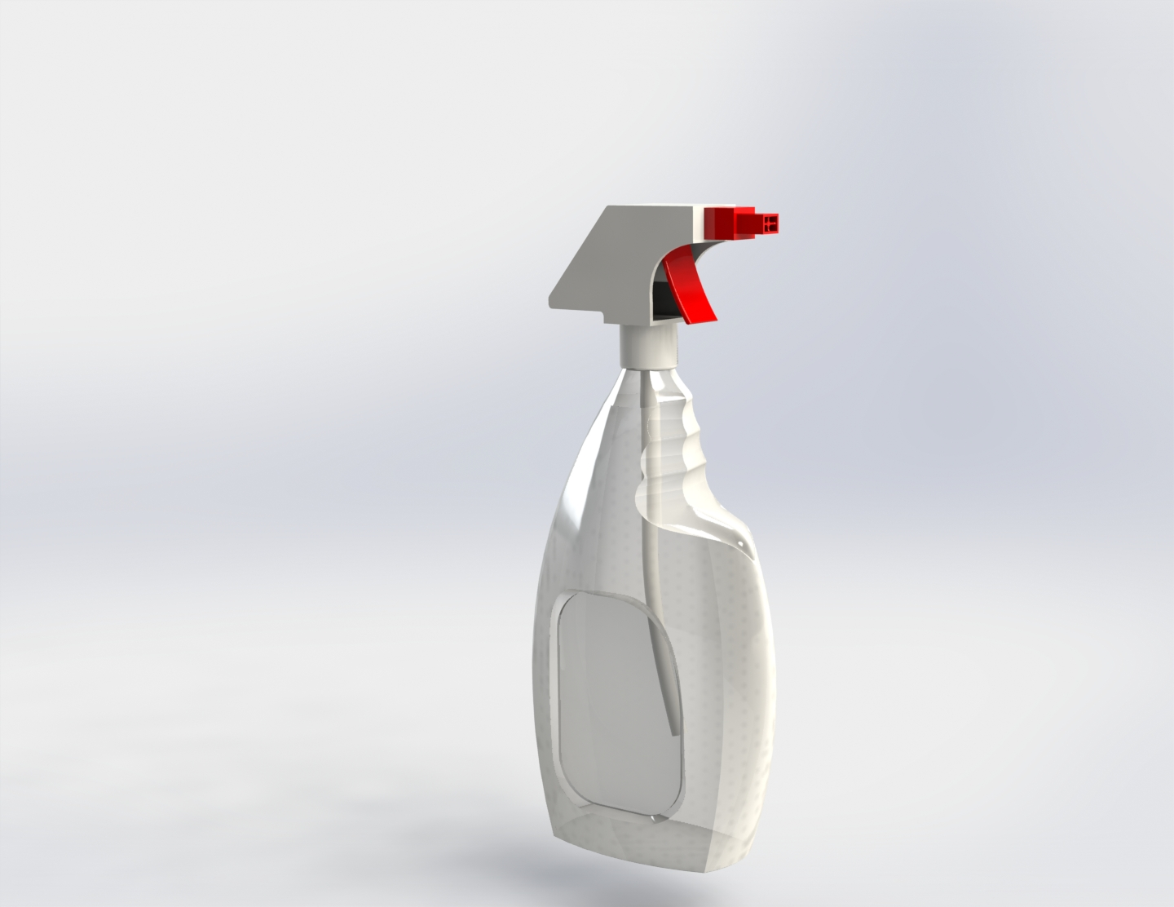

Spencer Pitt

Cedarcrest High School

1/19/2022

1. **Introduction (2 points)**
   1. Introduction paragraph(s) gives an overview of the project. Tell what the project is in general and specific terms.

**The Spray Bottle is a model of a Spray Bottle using surface lofts using multiple sketches and planes. The Spray Bottle is meant to be a recreation of what you would see on someone's counter in their house. It has a working trigger and straw to bring the liquid to the custom made nozzle.**

1. **Target Market (2 points)**
   1. Give a description of who would use the product and / or a customer list. (It could be a design for one specific user.)

**The spray bottle is meant to be used by people in the modeling and videogame industry, it can be used as a prop in other models to add to the ambience of the render or scene, it can also be used by video game designers as a prop or background model in the game.**

1. **Requirements (4 points)**
   1. Tell what requirements you were trying to have your project meet.
   2. Give specific and appropriate supporting details. Use as many paragraphs as needed to fully explain. (You may also embed screen shots.)

**With the spray bottle project, I was attempting to challenge my skills with surface lofts and other surface features. I wanted to make a realistic looking spray bottle that would be good enough to be a prop in the background of other renders to add to the ambiance.**

1. **Product Ideas (4 points)**
   1. How did you come up with your product? What were some ideas you had when developing your design?
   2. Describe how you decided on the project, how you met the requirements with your design.

I came up with the project idea by

1. **Product Sketches (4 points)**
   1. Include your sketches and descriptions of those sketches. (The sketches can be in the appendix.)
2. **Success in Creating Product (4 points)**
   1. Answer the question: How successful were you in creating the product?
   2. Give specific and appropriate supporting details. Use as many paragraphs as needed to fully explain. (You may also embed screen shots.)

**I was extremely successful in creating the Spray Bottle by making a realistic looking Spray Bottle with a spray trigger and straw. The model looked great in renders vastly improving the marketability of the product with the professional looking renders.**

1. **Lessons Learned (4 points)**
   1. Answer the question: What lessons did you learn (at least 2) that were not modeling or rendering skills. Such as what you would do again and what you would not do again.
   2. Give specific and appropriate supporting details. Use as many paragraphs as needed to fully explain. (You may also embed screen shots.)

**During the project I learned how to better understand how to model real life organic objects, the project opened my view on what parts make up these organic objects and how to segregate them into smaller more achievable parts. I also learned how to take better inspiration from real life objects as opposed to items that don’t exist in real life, this has allowed me to improve the overall model quality**

1. **Skills Learned (4 points)**
   1. Answer the question: What specific technical skills did you learn? And tell how you would teach at least one skill.
   2. Give specific and appropriate supporting details. Use as many paragraphs as needed to fully explain. (You may also embed screen shots.)

**I learned how to use the surface loft tool which has allowed me to create harder shapes that wouldn’t normally be able to model with the normal boss extrudes. If I were to teach them the skill, I would start by having them create a umbrella as it’s a great shape to teach that feature with.**

1. **Description of Product Drawings (2 points)**
   1. Describe the drawings that you have for your project. Point out specific details in your drawings of how your project met the requirements you set out to meet.

**The drawings show the use of the surface lofts and features along with my goal of making a realistic spray bottle that includes the lid and straw assembly.**

1. **Product Drawings (6 points)**
   1. Include product drawings with appropriately filled in title blocks, dimensions, notes, etc.
2. **Product Renderings and/or Physical Models (4 points)**
   1. Put together enough renderings to show off your product. (3) These renderings (and /or pictures of physical models) must show case the product in the best light for customers or potential customers to want to obtain the product. Also give a short explanation of how you would go about appealing to customers (1).

**I would use these renders to show off their usability in scenes for other renders and other pieces of media. The renders would help give a mental image of what the Jack O Lantern could be used for in other scenarios.**

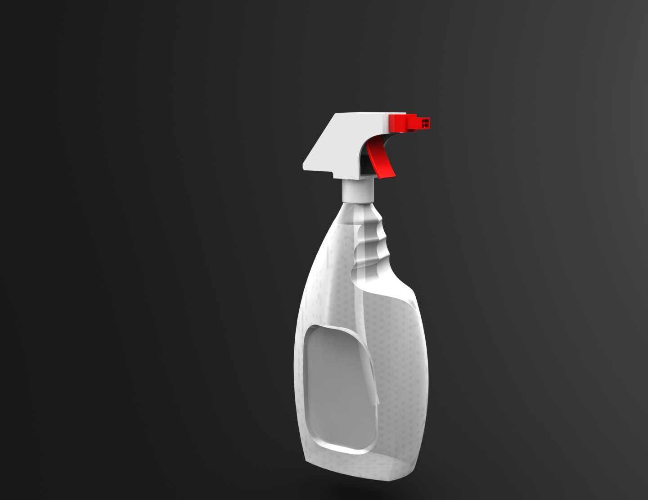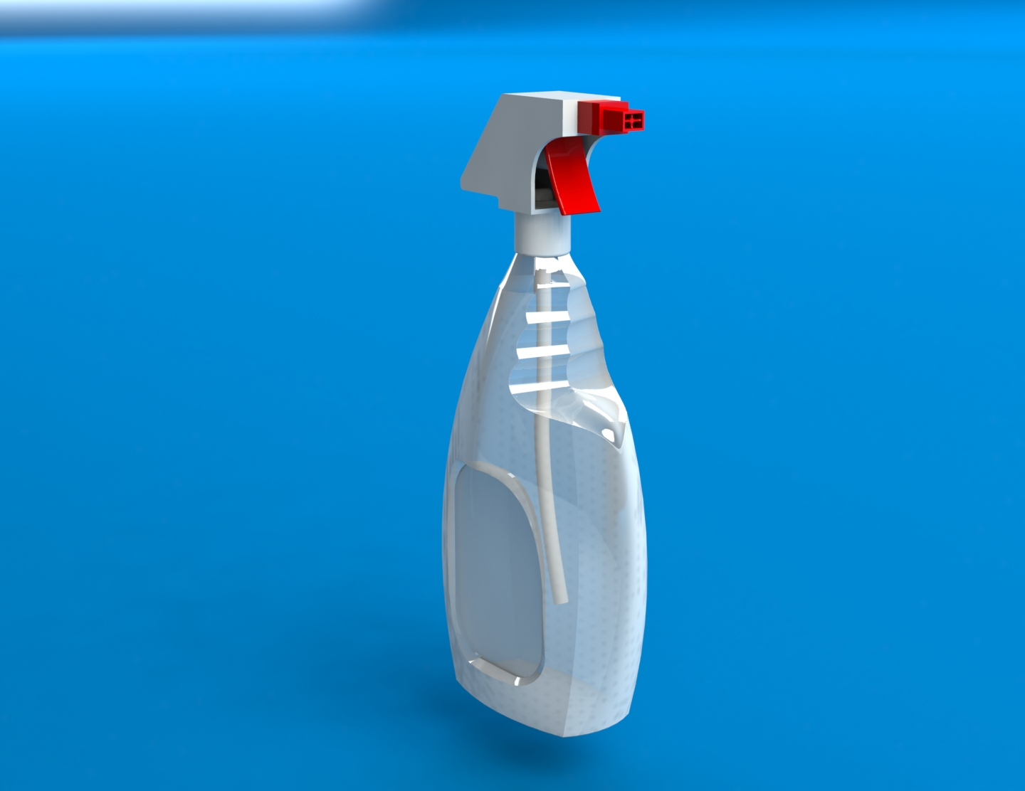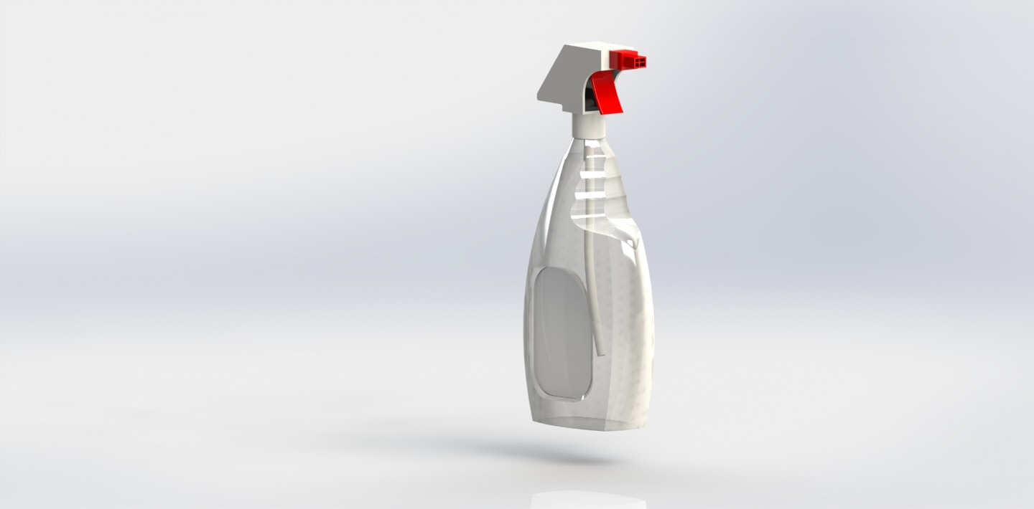

**Appendix/Notes**

You can put other notes or thoughts into the Appendix/Notes section. These are thoughts or notes that do not fit into the other categories but add to the understanding of the product. The Appendix/Notes section may be deleted if not used.

By the way, edit the header (put the title of your project) and footer (replace “Name” with your name so that it appears on each page).